The Nutrient Cycles
The Water Cycle
- Water cycles between the oceans, atmosphere and land. All living organisms require water.
  - Water enters the atmosphere as _________ ________, a gas, when water evaporates from the ocean or other bodies of water.
    - ____________—the process by which water changes from a ________ to a __________.
  - Water can also enter the atmosphere by evaporating from the leaves of plants_______________.
  - Precipitation-____________________________________________________
    - The sun heats the ___________________________.
    - Warm, moist air rises and cools.
    - Eventually, the water vapor condenses into tiny droplets that form ____________.
    - When the droplets become large enough, the water return to Earth’s surface.
  - ____________________—Precipitation runs along the surface of the ground until it enters a river or a stream that carries the run-off back to an __________ or lake.
  - ______________—Rain also seeps into the soil, some of it deeply enough to become _________________________. Water in the soil enters plants through the ______________, and the water cycle begins anew.

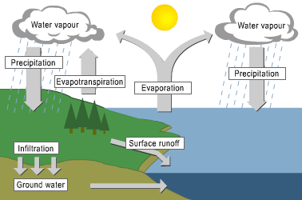

The Carbon Cycle
- Every _______________ molecule contains the element _______________.
  - Carbon and oxygen form ______________ gas (CO₂), an important component of the _______________.
  - Carbon dioxide is taken in by plants during _______________ and is given off by plants and animals during ___________________________.
- Four main types of processes move carbon through its cycle:
  - Biological processes, such as _____________, ________________, and ________________, take up and release carbon and oxygen.
  - Geochemical processes, such as _____________ and volcanic activity, release carbon dioxide into the atmosphere and oceans.
  - Mixed biogeochemical processes, such as the burial and decomposition of ____________________ and their conversion under pressure into ___________ and ____________(fossil fuels), store carbon underground.
  - Human activities, such as _______________, cutting and _______________ forests, and burning ____________, release carbon dioxide into the atmosphere.
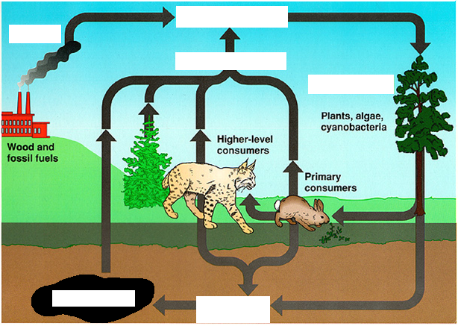

The Nitrogen Cycle
- All organisms require nitrogen to make amino acids, which in turn are used to build _______________.
  - Nitrogen gas makes up 78% of Earth’s atmosphere.
  - Nitrogen containing substances such as ammonia (NH₃), nitrites (NO₂⁻), and nitrates (NO₃⁻) are found in the wastes produced by many organisms and in dead and decaying organic matter.
  - Nitrate is major component of plant ______________.
- Nitrogen gas is the most abundant form but only certain _______________ can use this form.
  - Such bacteria live in the _________ and on the ____________ of plants.
  - These bacteria convert nitrogen gas into ammonium--__________________________________.
  - Other bacteria in the soil convert ammonia into nitrites and nitrates.
- Once the nitrites and nitrates are available, ___________ (plants) can use them to make ________. ______________ then eat the producers and reuse the nitrogen to make their own proteins.
- When organisms die, _____________________ return nitrogen to the soil as ammonia.
- Other soil bacteria convert nitrates into nitrogen gas--denitrification. This process releases nitrogen into the atmosphere once again.
